**Searching for Recipes**

From our whiteboarding session, one of the 3 ideas we decided to polish was the ability to search for a given recipe.

The initial searching landing page proposed to the group. This would allow users to search for a given tag/recipe and would also have a recently searched functionality to allow users to quickly go back to recipes they’ve used before

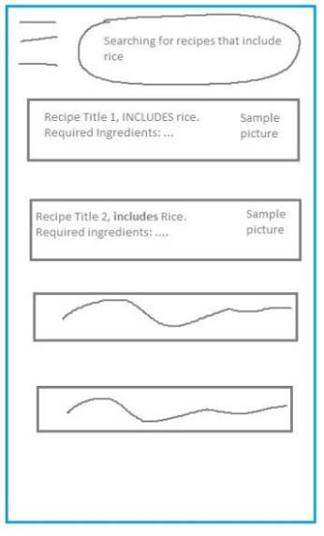

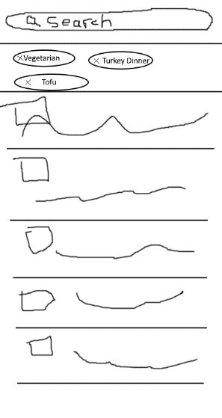  
  
  
These images were proposed with the addition of tags to a given search and the results of what a given search could possibly look like. This would allow users to search for multiple tags to further fit what they’re looking for out of the recipe. Once one of these recipes would be clicked it was decided that it would bring you to the recipe’s “landing page”.

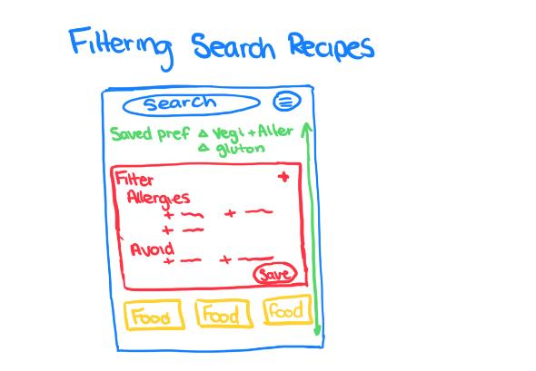

The idea of adding saved features for possible allergies or possible intolerances to given foods was also proposed. This would add functional customizability to the app for people that have issues eating certain foods. Making it easier for users to come in and use the app the way it would suit them the best.

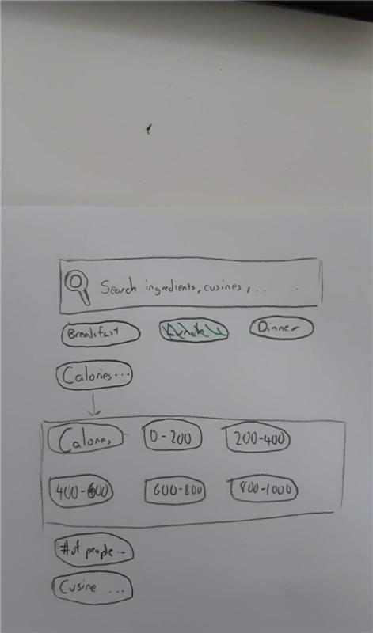The drawing of allowing for caloric intake tag would also allow users to use the app for a dieting app. Making it so that users that are trying to follow a diet program can accurately predict the caloric intake for a given recipe making their search more streamlined towards their needs.